***1)Class Diagram For Online Voting System***

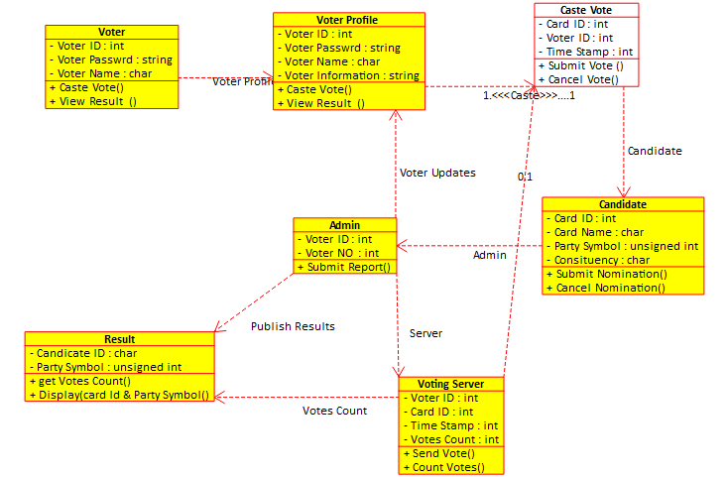

***2)Class Diagram For Library Management System***

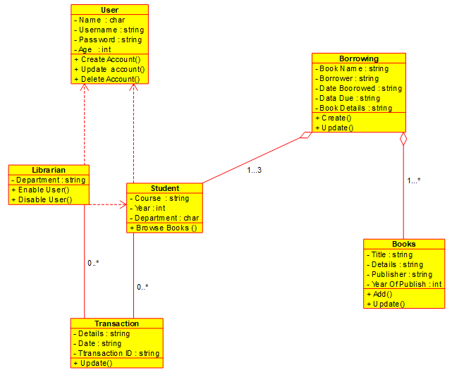

***3)Class Diagram For an E- Library online Public Access Catalogue***

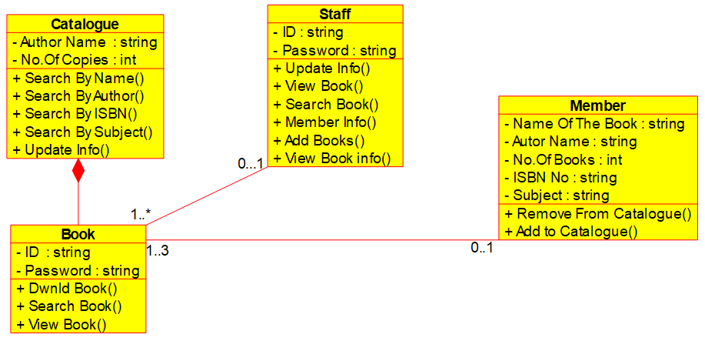

***4)Class Diagram For a Restaurant Mnanagement system***

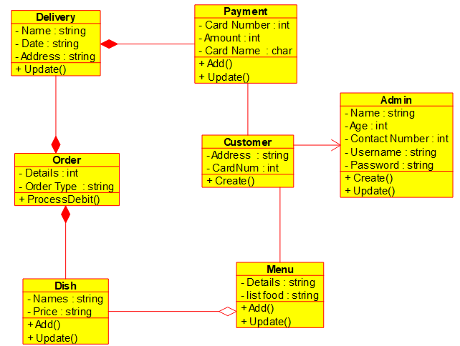

***5)Class Diagram For a Quiz***

